Lab 2 Part 1 Questions

1)

|  |  |  |  |  |  |  |  |
| --- | --- | --- | --- | --- | --- | --- | --- |
|  | 10 | 100 | 1000 | 10,000 | 100,000 | 10^6 | 10^7 |
| Time (clicks) multi | 48812 | 50884 | 51591 | 57253 | 121875 | 822917 | 2.54sec |
| Time (clicks)  single | 1681 | 185 | 1940 | 23480 | 201573 | 2231791 | 0.84sec |

Table 1. Multithreading run with 10 threads. Highlighted column is where multithreaded program overtook the single threaded.

2)

My machine has 6 cores so expected 6 times speedup if using 6 or more threads.

3)

Did not achieve expected speedup. Only reached ~3.1x speedup at 6 threads and 3.57x speedup at 100 threads. The threads being joined before the subarrays are merged into the final array could be limiting the speed of the program.

4)

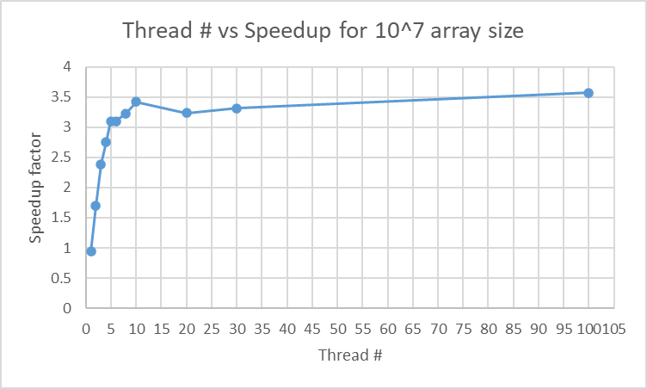

Figure 1. Speedup factor diminishes around 6 threads as expected for a 6 core machine.